Posting type Information
Subject Change in the analytical protocol for XRF analysis of CSN samples
Sites Entire network
Period Jan 2019 to present
Samples affected October 2018 and forward
Submitter K.Trzepla, ktrzepla@ucdavis.edu

Supporting information
The element content of collected CSN samples is quantified by energy-dispersive x-ray fluorescence (EDXRF) analysis. Typical CSN mass loadings are close to the EDXRF detection limits for several elements, and it is challenging for EDXRF systems to provide good determinations. In November 2015, the laboratory performing the EDXRF analysis changed from Research Triangle Institute (RTI) to University of California at Davis (UCD). The EDXRF instruments used by these two laboratories use different techniques for exciting the samples – direct excitation (RTI) with a single source spectrum at full intensity, versus secondary excitation (UCD) from secondary targets providing a sequence of different spectra at lower intensities – and the two techniques are most advantageous for different elements. After analyzing CSN samples for several months, we determined that the detection limits for several elements, particularly heavier elements, had increased when the laboratory changed. More details on these changes can be found in the National Ambient Air Monitoring Conference presentation, https://projects.erg.com/conferences/ambientair/conf18/White_Warren_Speciation_8-15_1030_SalonF_POST_508.pdf.
In order to obtain lower detection limits for some of the elements reported in CSN (e.g. Pb), the analytical protocol for XRF analysis was modified. The secondary targets and times on each of the targets were optimized to provide best possible excitation and allow to reach acceptable determination levels. Table 1. below shows the protocol utilized before January 2019 with the modified protocol applied for all subsequent analysis starting in January 2019.
Table 1.
Old protocol (before Jan 2019) New protocol (from Jan 2019)
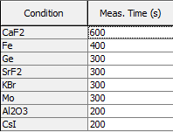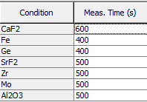

The XRF analyzers were recalibrated in January 2019 and the mass loadings reported for all CSN samples starting October 2018 are being reported with the new calibration and new analytical protocol.
Effects of the applied changes, including detection limits, will be evaluated when sufficient data (at least 6 months) are collected, and the results will be documented in an additional advisory and presentation.

